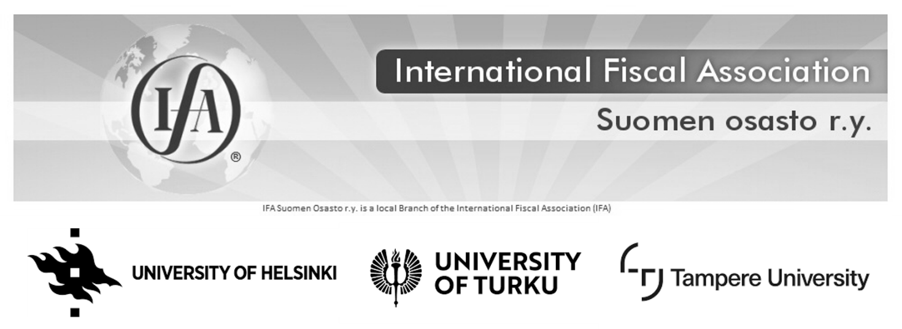
IFA Nordic Regional Conference 2019
Tax Challenges of Digitalization and
Recent Trends in the Anti-tax Avoidance Scene
Helsinki
14 – 15 March 2019

The Finnish IFA Branch, with support from the Swedish, Danish and Norwegian IFA Branches, the Law Faculties at the University of Helsinki and University of Turku and the Faculty of Management at the Tampere University, and with the support of the Transformation of the International Tax System research project organizes a Nordic IFA conference on Tax Challenges of Digitalization and Recent Trends in the Anti-tax Avoidance Scene. The conference will take place in Helsinki, Finland, on 14 and 15 March 2019. It will begin at 12.00 on Thursday 14 March, and close at 12.00 on Friday 15 March, enabling participants from the other Nordic countries to fly in on Thursday morning and fly back Friday afternoon. A social event is planned for Thursday evening.

The conference venue Roschier Building (Kasarmikatu 21) is at the centre of Helsinki. Accordingly, there are various hotels conveniently located, e.g. Sokos Hotels on Kluuvikatu 8, Yrjönkatu 26 and Asema-aukio 2. Minna Vennamo will answer any questions regarding the conference at minna.vennamo@fiskars.com.

To register, please send the attached registration form to minna.vennamo@fiskars.com and pay the conference fee of 350 euros. Payment details are in the registration form. Please note that registration is completed only after the payment is visible in the bank account of IFA Finland.

Registration is open until Wednesday 6 March.

You are most welcome!

Marjaana Helminen
Professor
Chair of Finnish IFA Branch
CONFERENCE PROGRAMME
(DRAFT, SUBJECT TO CHANGE)

14 March 2019

Venue: Roschier Building, Kasarmikatu 21, Helsinki

12.00 – 12.15 Opening of the conference
Professor Marjaana Helminen, University of Helsinki, Chair of IFA Finland

SUBJECT I: TAX CHALLENGES OF DIGITALIZATION

Chair Professor Arvid Skaar, University of Oslo (Norway)

12.15 – 12.45 Taxation of the digital economy – what is it about and what not
Dr. Martti Nieminen, University Lecturer, Tampere University (Finland)

12.45 – 13.30 Digital PE concept
Professor Pasquale Pistone, Academic Chairman of IBFD (Netherlands)

Short break

13.45 – 14.30 Attribution of profits to new nexus rules
Dr. Vikram Chand, Executive Director - International Tax Education, Tax Policy Center at University of Lausanne (Switzerland)

14.30 – 15.00 A Nordic perspective on the taxation of digital business
Timo Ohvo, Tax Manager, Nokia (Finland)

15.00 – 15.30 Panel discussion on tax issues arising in the context of the digital economy for the Nordic Countries

Moderator: Prof. Arvid Skaar University of Oslo (Norway)
Panelists:
Dr. Martti Nieminen, University Lecturer, Tampere University (Finland)
Prof. Pasquale Pistone, IBFD (Netherlands)
Dr. Vikram Chand, Executive Director, University of Lausanne (Switzerland)
Timo Ohvo, Tax Manager, Nokia (Finland)

15.30 – 16.00 Coffee break

SUBJECT II: RECENT TRENDS IN THE ANTI-TAX AVOIDANCE SCENE

Chair Professor Marjaana Helminen, University of Helsinki (Finland)

16.00 – 16.30 Beneficial ownership concept and the recent ECJ cases
Arne Møllin Ottosen, Partner, Kromann Reumert (Denmark)

16.30 – 17.00 Will be specified later.

17.00 – 17.30 Will be specified later.

17.30 – 18.00 Interest limitation provisions: Sweden
Associate Professor Jérôme Monsenego, Stockholm University (Sweden)

18.00 – Social program. Will be specified later.

15 March 2019

Venue: Roschier Building, Kasarmikatu 21, Helsinki

SUBJECT II CONTINUES

Chair Associate Professor Jérôme Monsenego, Stockholm University (Sweden)

9.00 – 9.45 Hybrid Mismatches and EU law
Professor Cécile Brokelind, Lund University (Sweden)

9.45 – 10.30 EU Commission’s powers concerning tax policy and tax legislation
Professor Emeritus Frans Vanistendael (Netherlands)

10.30 – 11.00 Coffee break

11.00 – 12.00 Panel discussion on recent trends in the anti-tax avoidance scene

Moderator: Ass. Prof. Jérôme Monsenego, Stockholm University (Sweden)
Panelists:
Arne Møllin Ottosen, Partner, Kromann Reumert (Denmark)
Prof. Cécile Brokelind, Lund University (Sweden)
Prof. Emer. Frans Vanistendael (Netherlands)

12.00 Closing of the conference
Professor Marjaana Helminen

Please note that there is no lunch provided at the conference. However, there is a lunch restaurant at the venue.

REGISTRATION

To register,

- Fill in and send this registration form to minna.vennamo@fiskars.com.
- Pay the conference fee of 350 euros with the following bank details.
RECIPIENT: International Fiscal Association Suomen osasto ry
IBAN: FI8115723000203984
BIC NDEAFIHH

Registration is open until 6 March.

Name of the participant:

____________________________________________________________________

Company/organisation/university:

____________________________________________________________________

Special diet:

____________________________________________________________________

Phone:

____________________________________________________________________

Email:

____________________________________________________________________

Address:

____________________________________________________________________

Transformation of the International Tax System is a 4-year research project on international tax law funded by the Academy of Finland and Tampere University. For more information, see project website at research.uta.fi/inttax.

