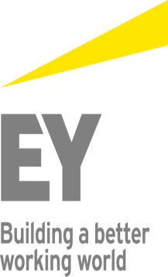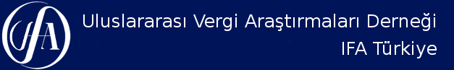

IFA TURKEY
ve
ERNST&YOUNG

Workshop - 11
27 September 2019, Friday
EY Zeugma Meeting Room
14.00 - 17.00

IFA 2020 CANCUN CONGRESS TURKISH REPORT
"Reconstructuring the Treaty Network"

Reporter: Abdulkadir Kahraman (EY)

Moderator
Erdal Çalıkoğlu (EY)

Venue: Maslak Mahallesi, Eski Büyükdere Caddesi, Orjin Plaza No:27 K:1, Zeugma Toplantı Odası, Sarıyer, İstanbul

