Taxes Chasing Billionaires
Date and time: November 13, 2025 – 12:00 PM (Brazil) / 5:00 PM (Switzerland).
The event will analyze recent developments in wealth taxation, both from a theoretical and a practical perspective, with a special focus on Europe and Latam.

Moderador:
Eduardo Barboza Muniz
- E-mail: emuniz@bde.com.br
- Short bio: Tax Partner at BDE Advogados. Master of Laws (University of São Paulo). Member of the YIN/IFA Committee. Tax Professor (IBET, IBMEC and FGV).

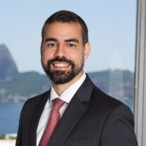

Marta Isabel Martins Costa dos Santos
- E-mail: martacostasantos@hotmail.com
- Short bio: PhD in Law (University of Coimbra). Tax Professor at the University of Coimbra.

Biografia completa
Marta Isabel Martins Costa dos Santos holds a PhD from the Juridical and Political Sciences Department of the Faculty of Law of the University of Coimbra, Portugal, where she is also a Visiting Assistant Professor, teaching Constitutional Law and Tax Law. Since January 2022, she has been a member of the Cabinet of the President of the Portuguese Supreme Administrative Court. She has participated in several congresses and conferences and has published mainly in the field of tax law. In 2024, she was appointed to the Commission to draft the General Regime of Public Administration Fees in Portugal.
Tópicos a serem abordados
- Global overview of key challenges in taxing HNWIs: declining effective tax rates at the top, transparency progress vs. blind spots, erosion of tax bases, enforcement priorities
- Comparative look at how individual jurisdictions have responded to these challenges

Dr. Natalja Žitkevitš
- E-mail: nzitkevits@pictet.com
- Short bio: PhD in Law (Jagiellonian University). Wealth Planner (Banque Pictet). Executive Committee Member (Eastern European Market).


Biografia completa
Natalja Žitkevitš is Senior Wealth Planner and Member of the Executive Committee of the Eastern European Market at Banque Pictet, which she joined in 2018. She advises Central and Eastern European high-net-worth individuals and families on international estate planning, wealth preservation, international private law, and wealth transfer solutions. Previously, she worked for eight years as Wealth and Tax Planning Advisor and Legal Counsel for financial and trust service institutions in Switzerland. Her earlier career focused on human rights, refugee law, and legal education.
Natalja holds a Doctor in Law degree from the Jagiellonian University in Cracow, where she also completed master’s degrees in Law and Latin American Studies. She pursued postgraduate studies in International Commercial Law at the University of the Andes in Bogotá. She is the author of a book and several articles on international law and is a member of STEP, EAPIL, ASADIP, and AiSDC. She speaks Polish, Russian, English, Spanish, and Estonian.
Tópicos a serem abordados
- Comparison of preferential regimes for wealthy individuals: Switzerland, Italy, and Poland (with reference to the UK res non dom regime)
- The future of wealth tax in Europe, including a potential federal inheritance tax in Switzerland
- Eastern European angle: Polish law on Family Foundations and its impact on wealth and inheritance taxation

Inés Cánepa Savio
- E-mail: ines.canepa@blumontadvisory.com
- Short bio: Founder of BLUMONT. LLM (WU Vienna). International Tax Advisor.

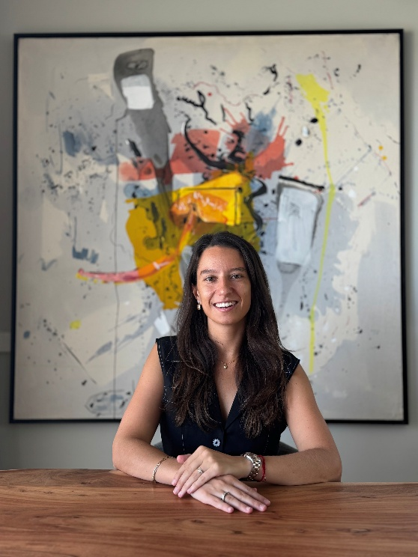

Biografia completa
Inés Cánepa Savio, CPA, BBA, LL.M., is an international tax advisor and the founder of BLUMONT, a boutique firm specialized in cross-border tax and estate planning. She holds an LL.M. in International Tax Law from WU Vienna (graduated with honors) and a Postgraduate Degree in International Taxation from Universidad de Montevideo. Before founding BLUMONT, she worked as Director of International Tax at Innovation Legal/Tax/Tech and completed a secondment at Cuatrecasas Madrid. Her practice focuses on advising UHNWIs, family offices, elite athletes, and internationally mobile clients, with particular expertise in special tax regimes and US-related structures.
Tópicos a serem abordados
(aguardando detalhamento específico; atualmente a bio não traz os tópicos da fala)

Caio Malpighi
- E-mail: cmalpighi@vieirarezende.com.br
- Short bio: Assistant Professor of Tax Law (IBDT). Tax Associate (Vieira Rezende Advogados). Researcher at NUPEM/IBDT and NEF/FGV.
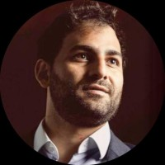

Biografia completa
Caio Malpighi is Senior Tax Associate at Vieira Rezende Advogados, Assistant Professor of Tax Law at IBDT, and Legal Counsel at Associação Brasileira das Empresas de Luxo (ABRAEL). He is also a researcher at NUPEM/IBDT and NEF/FGV. His academic and professional practice focuses on Brazilian tax law with an emphasis on high-net-worth individuals and corporate structures.
Tópicos a serem abordados
- Anti-deferral rules under Law 14.754 (CFC rules for individuals)
- Higher inheritance and gift taxation (rates and taxable events)
- Ongoing congressional debates on additional tax on high incomes and dividend taxation

